**1) Create web pages using basic HTML Tags, Table ,List, Image, and Frame Tags.**

**Basic Html Tags:**

<html>

<head>

<title> Basic HTML tags </title>

</head>

<body>

<center>

<pre> Heading tags: h1,h2,h3,h4,h5</pre>

<pre> List tags: ol,ul,li</pre>

<pre> Editing tags: i,b,em,strong,small,big</pre>

</center>

</body>

</html>

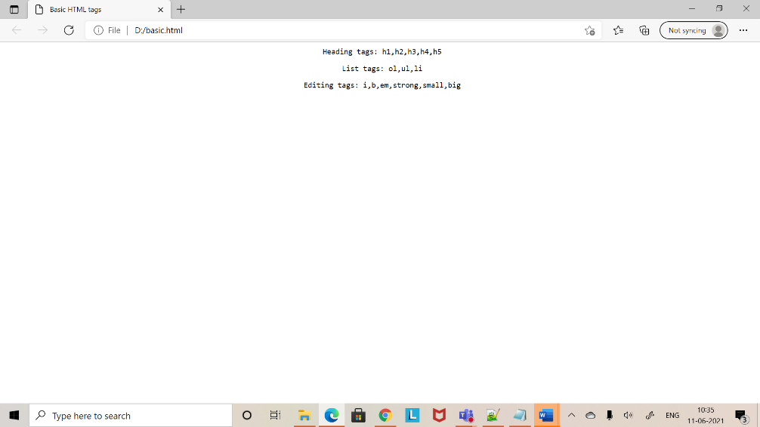

**Table:**

<html>

<head>

<title> TABLES </title>

</head>

<body bgcolor ="pink">

<center>

<h1> DETAILS OF EMPLOYEES </h1>

<table border="1">

<tr>

<th> COMPANY </th>

<th> CONTACT </th>

<th> COUNTRY </th>

</tr>

<tr>

<td> Alia </td>

<td> 8037446262 </td>

<td> Germany </td>

</tr>

<tr>

<td> Hema </td>

<td> 9464355252 </td>

<td> India </td>

</tr>

<tr>

<td> Janu </td>

<td> 7674637 </td>

<td> Europe </td>

</tr>

<tr>

<td> Ananya </td>

<td> 637864738 </td>

<td> USA </td>

</tr>

</table>

</center>

</html>

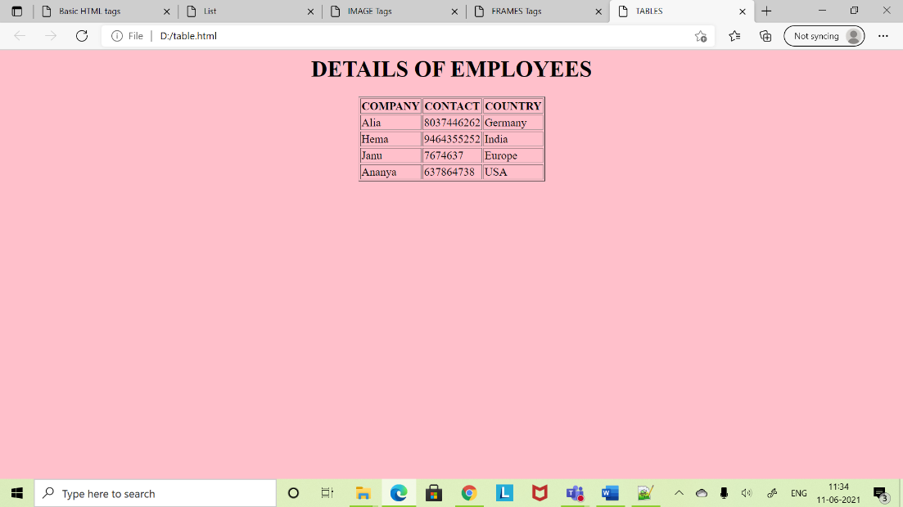

**List Tags:**

<html>

<head>

<title> List </title>

</head>

<body bgcolor="cyan">

<h1><Lists Demo</h1>

<h2> Number of subjects </h2>

<ol>

<li> WT </li>

<li> CN </li>

<li> DWDM </li>

<li> CN </li>

</ol>

<h3> LABS </h3>

<ul/>

<li> WT LAB </li>

<li> CN LAB </li>

<li> DWDM LAB </li>

</ul>

</body>

</html>

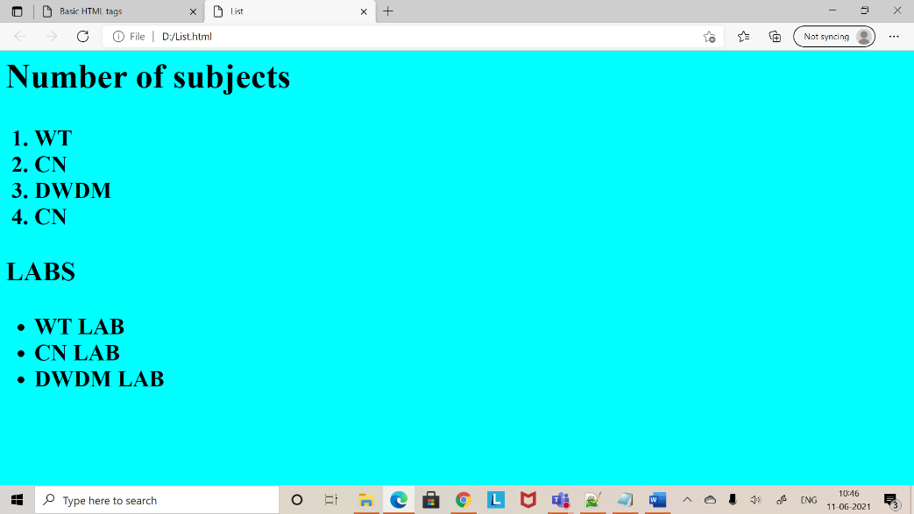

**IMAGE Tags:**

<html>

<head>

<title> IMAGE Tags </title>

</head>

<body>

<img src = "C:\Users\91949\Downloads\aditya_logo.png" height=200$,width=70%>

<p align="right"><img src="C:\Users\91949\Downloads\india_flag.jpg" height=300$,width=70%></p><br>

</body>

</html>

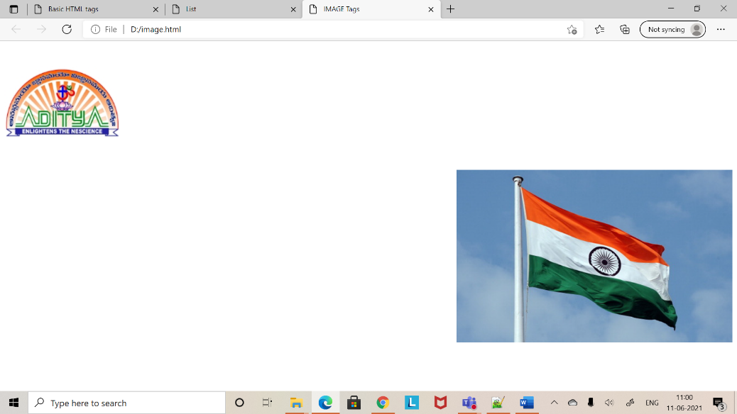

**FRAME Tags:**

<html>

<head>

<title> FRAMES Tags </title>

</head>

<frameset cols="40%,40%" rows="40%,40%">

<frame src="frame1.html">

<frame src="frame2.html">

<frame src="frame3.html">

<frame src="frame4.html">

</frameset>

</html>

**FRAME 1:**

<html>

<head>

<title> FRAME 1 </title>

</head>

<body bgcolor = "blue">

<h1>Frame1</h1>

</body>

</html>

**FRAME 2:**

<html>

<head>

<title> FRAME 2 </title>

</head>

<body bgcolor = "cyan">

<h1>Frame2</h1>

</body>

</html>

**FRAME 3:**

<html>

<head>

<title> FRAME 3 </title>

</head>

<body bgcolor = "pink">

<h1>Frame3</h1>

</body>

</html>

**FRAME 4:**

<html>

<head>

<title>FRAME 4</title>

</head>

<body bgcolor = "yellow">

<h1>Frame4</h1>

</body>

</html>

